Team Player Assignment

Roll No.: 243514

Name: Dhruva Rakesh B

Date: 28-03-2024

player (player_id, pname,speciality,date_of joining,num_matches,team_id) team(team_id, tname,player_num) matches(match_id, team1,team2,match_date,winner,man_of_the match) simple query

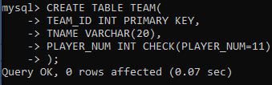

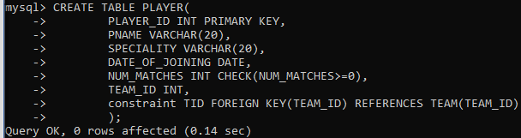

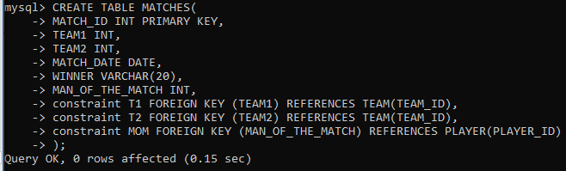

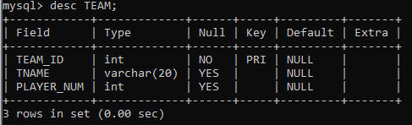

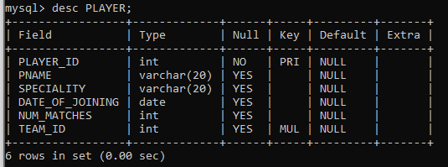

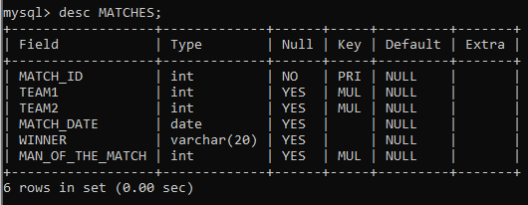

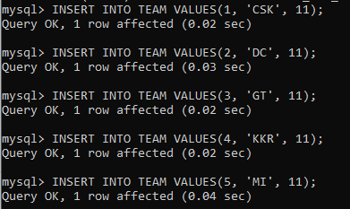

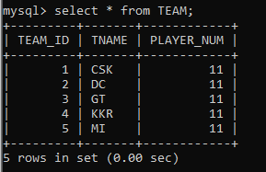

1. display all players playerid, player name and experience

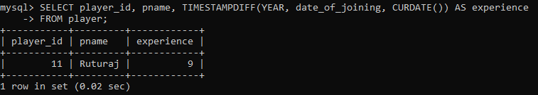

1. display all player with experience > 5 years

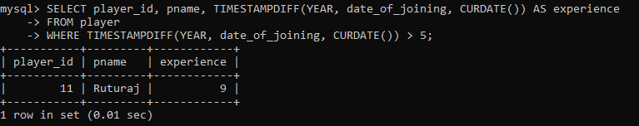

1. display all players joined in march month, any year

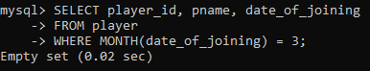

1. display all players joined in march 1995

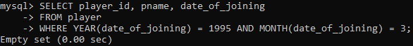

1. display all player with number of matches played are either 5 or 10 or 8

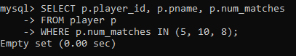

1. display all employees who are either batsman, bowler

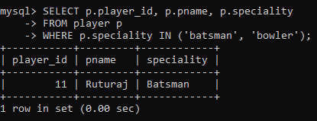

1. display all employees who joined in year 1995 or 1996 or 1997

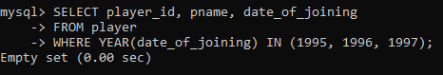

Nested query

1. list all player who plays in virat kohalis team

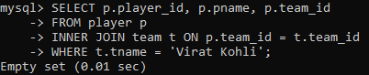

1. list all players who played matches in year 2024

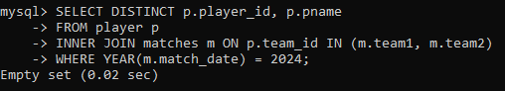

1. list all matches in which man of the match is from team1

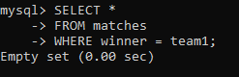

1. list all matches in which man of the match is from team1

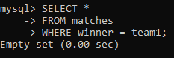

1. list all matches in which csk team win.

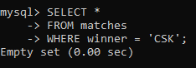

1. list all matches in which either csk or rcb team won the match

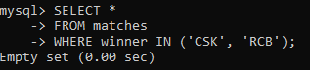

1. list all teams who one atleast one match

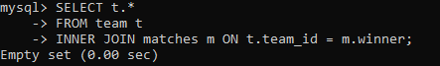

1. list all teams who does not played any match

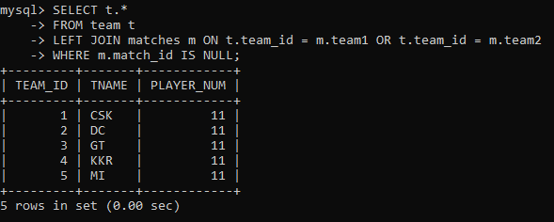

1. list all team name, in which no players are their

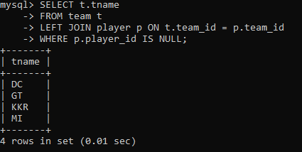

1. list all players who are in dhoni’s team

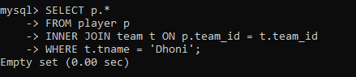

1. list all players who are in either dhoni’s or virat’s team

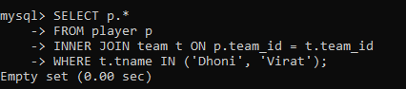

1. find all team names who one more than 3 matches

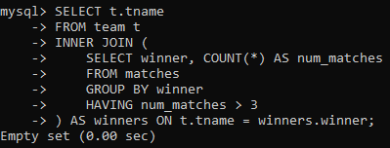

create following tables.

|  |  |  |  |  |
| --- | --- | --- | --- | --- |
| Table: Movies |  |  |  |  |
| **Id Title** | **Director** | **Year** | **Length_minutes** | **Release date** |
| 1 Toy Story | John Lasseter | 1995 | 81 |  |
| 2 A Bug's Life | John Lasseter | 1998 | 95 |  |
| 3 Toy Story 2 | John Lasseter | 1999 | 93 |  |
| 4 Monsters, Inc. | Pete Docter | 2001 | 92 |  |
| 5 Finding Nemo | Andrew Stanton | 2003 | 107 |  |
| 6 The Incredibles | Brad Bird | 2004 | 116 |  |

movieid is primary key year >1970 length_minutes>15 min and < 240 mins Release_date >1990-12-31 default ‘1991-01-01’ create table movie(movieid int primary key, title varchar(20), director varchar(20), year int chek(year>1990), length_min int check(length_min between 15 and 240) release_date date check(release_date>’1990-12-31’) default ‘1991-01-01’)

insert into movie values(1,'Toy story','John Lasseter',1995,81,'1995-03-02'); insert into movie values(2,'A Bugs Life','John Lasseter',1998,95,'1998-03-02');

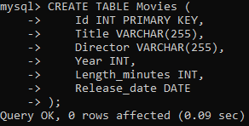

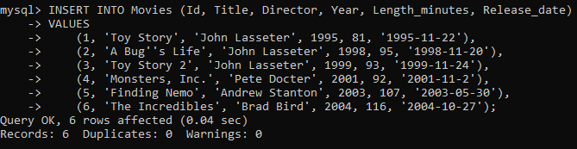

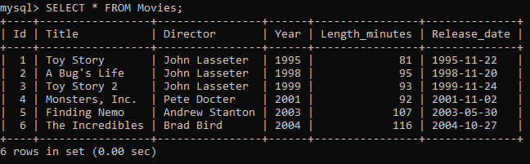

|  |  |  |  |  |  |  |  |
| --- | --- | --- | --- | --- | --- | --- | --- |
| Table: Boxoffice | | |  | |  | | |
| **Movie_id Rating** | | | **Domestic_sales** | | **International_sales** | |  |
| 5 | 8.2 | 380843261 | | 555900000 | |
| 14 | 7.4 | 268492764 | | 475066843 | |
| 8 | 8 | 206445654 | | 417277164 | |
| 12 | 6.4 | 191452396 | | 368400000 | |
| 3 | 7.9 | 245852179 | | 239163000 | |
| 6 | 8 | 261441092 | | 370001000 | |

